Bash Scripting-01
About bash scripting:- bash is very important for automation task it help save us time
- :- it can handle our task such as free -m, ps -ef, df, du -sk (login to server and verify every day.) it make our work fast simple
To automate all the above commands every day, we follow Bash Scripting.
Process below:-
Use micro or vi to write the commands for your script (the automation). After writing ur script make sure give it permission ( chmod 777 name)

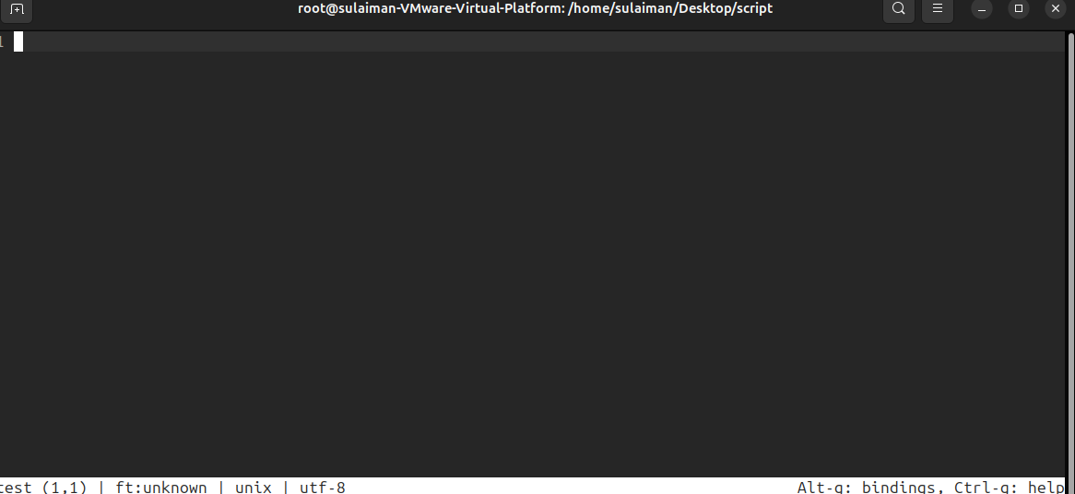
It our dash board where used write script excute it automation task

#!/bin/bash = it called Shebang It's a mandatory instruction that says, "Hey, computer! Use the Bash shell to read and run the rest of the commands in this file."
After writing script just save ur script press ctrl+s and quite ctil+q

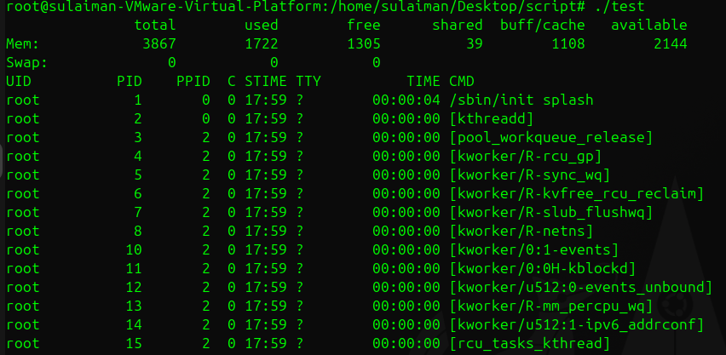
You can notice that our script is working

1 Which shell are you using right now
Command:-echo $0
Meaning: You are telling the computer: "Just tell me the name of the program I am currently using to type these commands
:- It usually prints back the name of the shell you are in, like bash.

Find all available shells on the system?
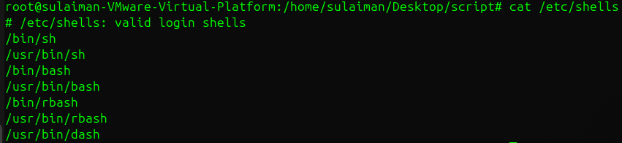
Command: cat /etc/shells
Meaning: The /etc/shells file is a master list of all the different command programs (shells) installed on the computer. The cat command is used just to read and display the contents of that file quickly.
:- You see a list of every available shell, such as /bin/bash, /bin/sh, /bin/zsh, etc.
Find out which shell each user uses?
Command: cat /etc/passwd
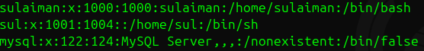
Meaning: The /etc/passwd file is a record that holds information for every user account on the system. You use cat to read this file. For each user listed, the very last piece of information on their line shows their default shell (the shell that starts when they log in).
Example: You see a list of users and the shell program assigned to them.

How to Change Your Shell Temporarily
Just type the name of the shell you want to use.
When you type the name of another shell (sh, csh, tcsh, etc.) and press Enter, your current shell immediately starts up the new shell on top of itself.
Here we are using :- sh shell
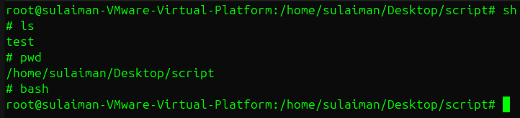
Here we are using :- cs shell
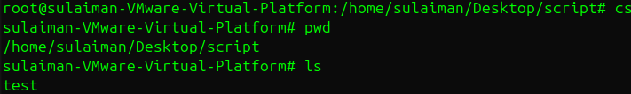
If went use your shell simple type ur shell name like bash and it switch ur shell
To find out absolute path and relative path, the below screenshot commands can be used.

Move into the folder
Confirm your current path

Create a new file called helloworld
In my case using micro text editior
Now inside micro, press i to insert
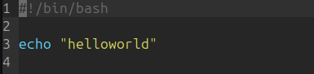
Type: ctrl+s to save
Ctrl+q to quite
Make the file executable

Run it using absolute path
Output should be:

Make sure you’re inside your scripts directory

Create a script with a meaningful name
Inside the editor, type:
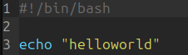
Save and exit:
( Ctrl+s ctrlq )
View your script contents:
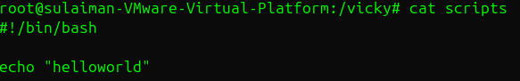
Go to your scripts folder
Rename your existing script
Verify the rename
View the script contents (optional check)
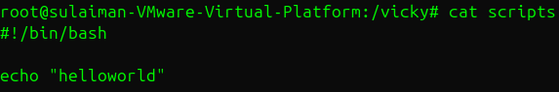

Script Format:
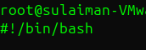
#! → called the shebang
/bin/bash → tells the system to use the Bash shell to run the script

Edit your script and make sure it starts with that line
cd /vicky/scripts
vi or micro helloworld.bash

Add Comments
Comments help others understand your script.
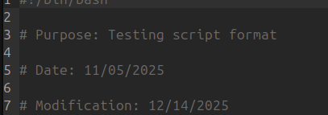 input

Define Variables
Variables store data inside scripts.
a='hello world'
Use Commands (echo, cp, grep, etc.)
echo $a
This prints the value stored in a
Optional Use Statements if, while, for, etc.
These are used to add logic — for example:
if [ $a == "hello world" ]
then
echo "The variable matches!"
fi
Complete Example Script:

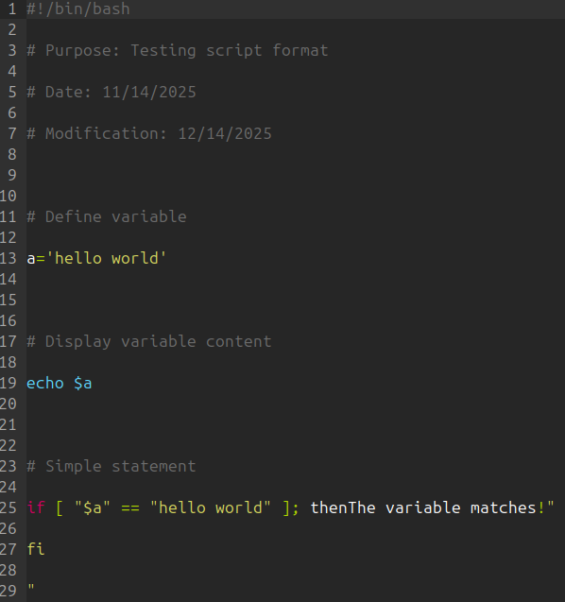 input
Basic Second Script
Create a new script file using micro
Micro testing1
Inside it
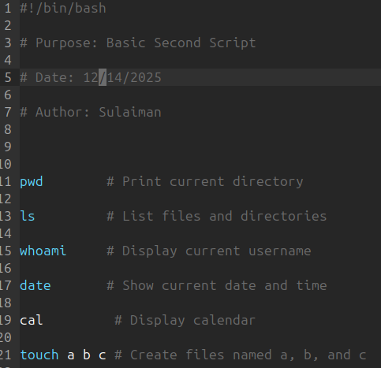
input
After giving permission chmod 777 testing1
Run our script
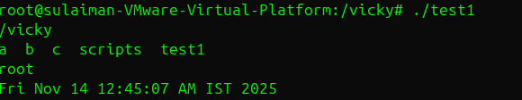 output
admin_tasks.bash explanation:
This script checks system health. It shows running processes (top), disk space (df -h), memory usage (free -m), system uptime, and disk I/O stats (iostat). Helps monitor server performance quickly.

Basic Administration Tasks
Create a new script in/ my case using testing2
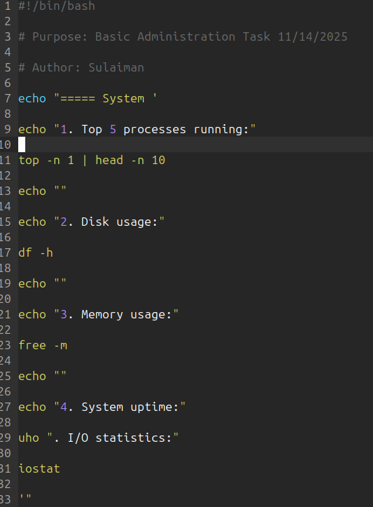

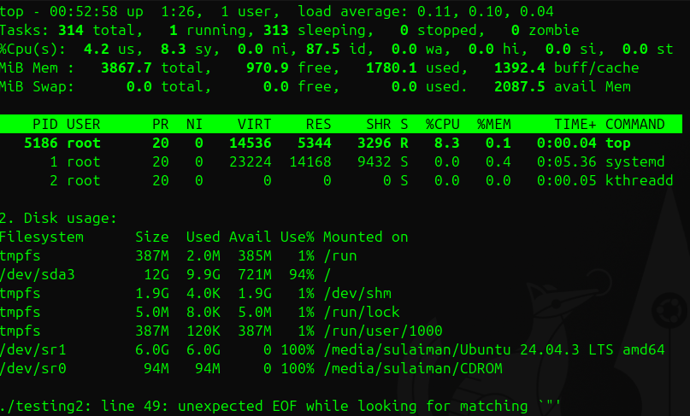
Command | Purpose
top | Displays real-time CPU and memory usage of running processes
df -h | Shows available and used disk space on all mounted file systems
free -m | Displays memory (RAM) and swap usage in megabytes
uptime | Shows how long the system has been running and the average system load
iostat | Reports CPU and disk I/O statistics (input/output performance)
 | Defining variables
Defining Variables in Bash
A variable is used to store data that can be reused or changed during script execution.
In Bash, we define a variable without spaces and use $ to access its value.

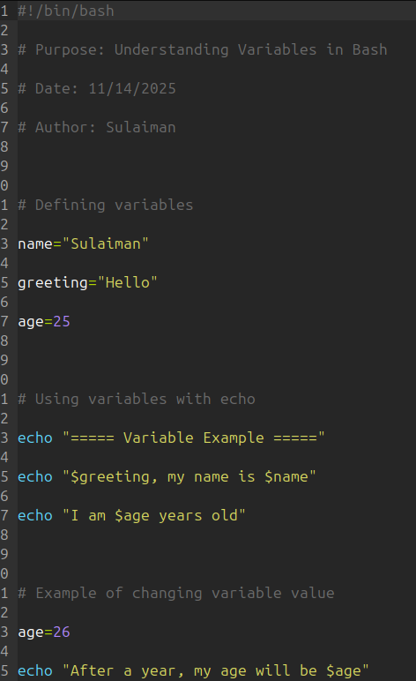
input
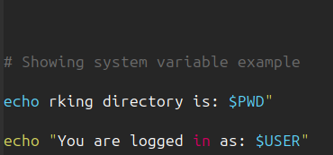
input
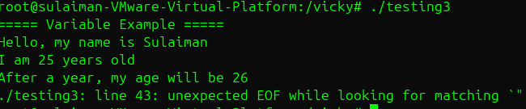
Output

